IT113A - IT Fundamentals
Final Project


Website link:
https://github.com/flordelizbayer-cell/Portfolio
Submitted by:
Instructor:
Loyd Anthony T. Gonzales

Flordeliza Bayer
IT113A
T280
November 2025

CONTENT

Introduction……………………………………………………………………… 1

Conceptual Design
Wireframe...................................................................................................................................... 2
Web Design……………………………………………………………………………………… 6
Web Hosting Service’s Implementation……………………………………………………… 10

Final Testing and Conclusion
Functionality Testing………………………………………………………………………...... 11
Recommendation for Future Work…………………………………………………………... 11
Conclusion……………………………………………………………………………………... 12
References……………………………………………………………………………………… 12

Introduction

The project entails the development of a personal portfolio website using HTML, CSS, and JavaScript, featuring a scrolling layout for smooth navigation. The website consists of three main interconnected webpages to ensure comprehensive functionality: the About page, the Project page, and the Contact page. The Home page serves as the landing page, showcasing detailed personal information, skills, and interests of the programmer. The Project page features the programmer’s first website project, developed for another subject. This foundational project is a portfolio website created using HTML and CSS, showcasing the initial skills and learning experience in web development. The Contact page provides essential contact information. A consistent navigation bar is integrated across all webpages to facilitate seamless and instant redirection between different sections, thereby enhancing the overall user experience. This structured design aims to create a polished and professional online presence as a programmer.

Once the construction of the website is finished, it will be hosted online so that it can be accessible for those who clicked the link. The chosen method for web hosting is utilizing GitHub Pages.

Fig 1. GitHub Logo
GitHub Pages is a static site hosting service that takes HTML, CSS, and JavaScript files straight from a repository on GitHub, optionally runs the files through a build process, and publishes a website. It can create GitHub Pages sites that are publicly available on the internet. Organizations that use GitHub Enterprise Cloud can also publish sites privately by managing access control for the site.

Conceptual Design

Wireframe
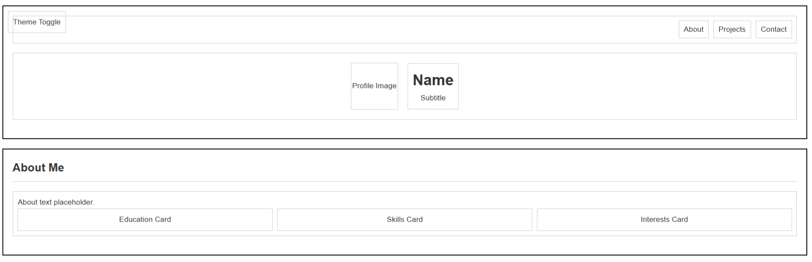
Fig 2. Home page Wireframe
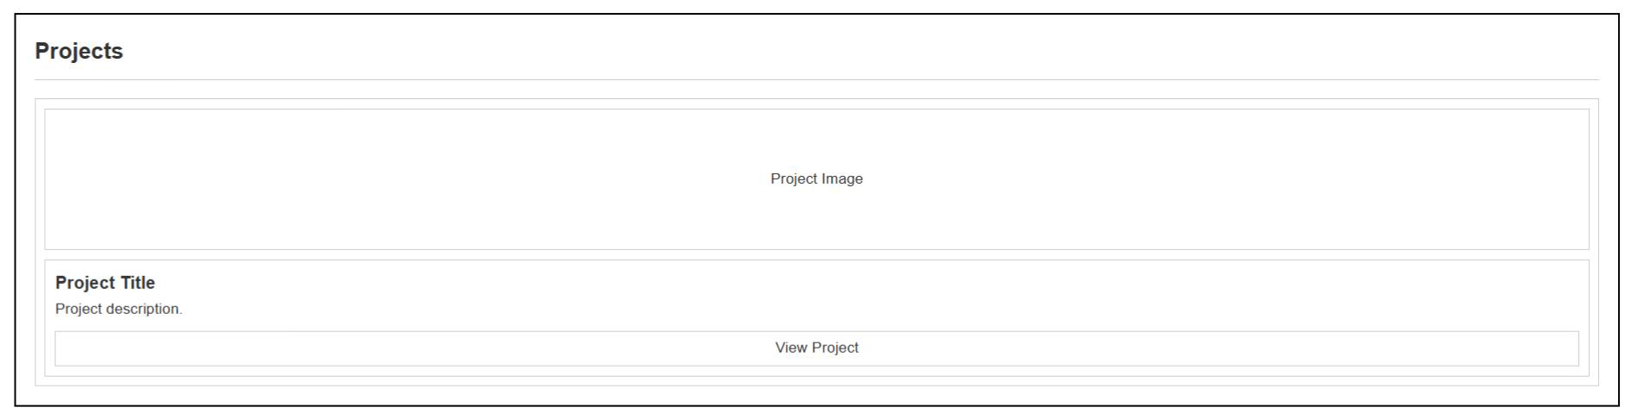
Fig 3. Project Page Wireframe
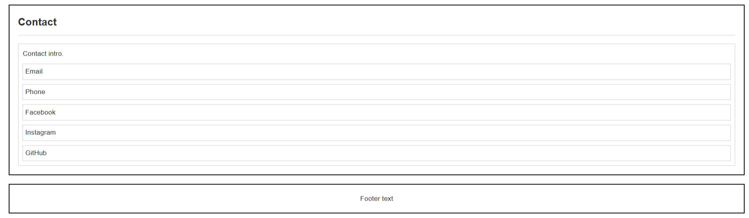
Fig 4. Contact Page Wireframe

Web Design



Fig. 5 Website Entry Page
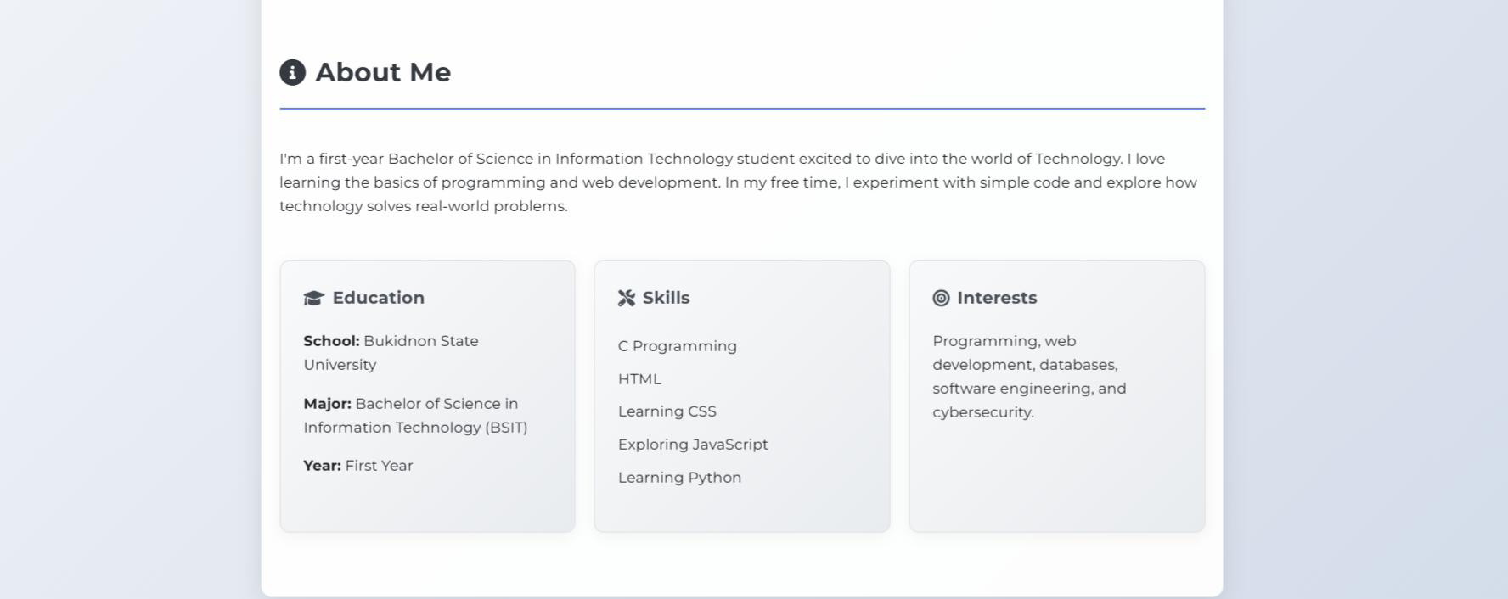
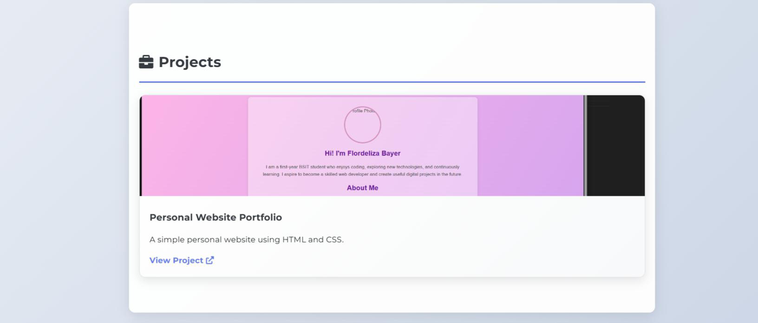
Fig. 6 About Page

Fig. 7 Project Page

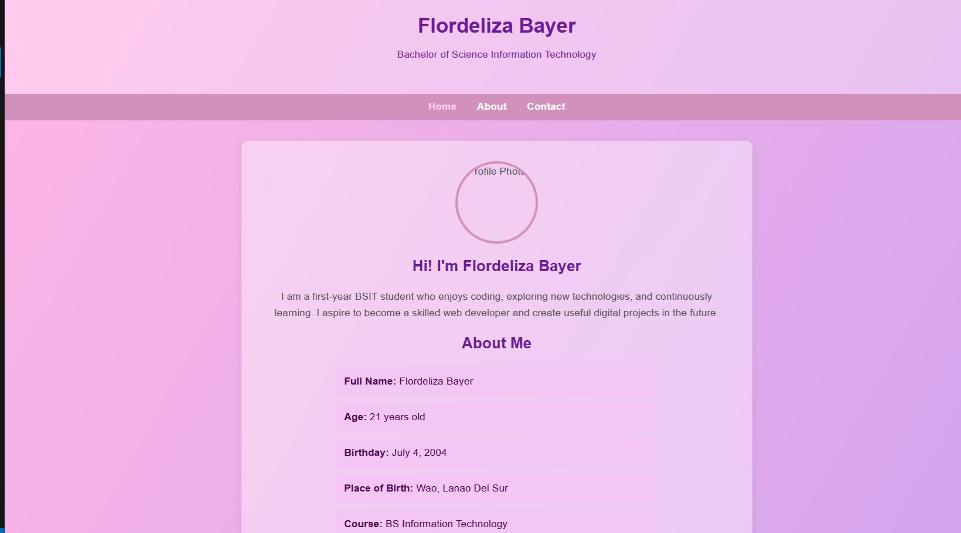
Fig. 8 Personal Project Portfolio
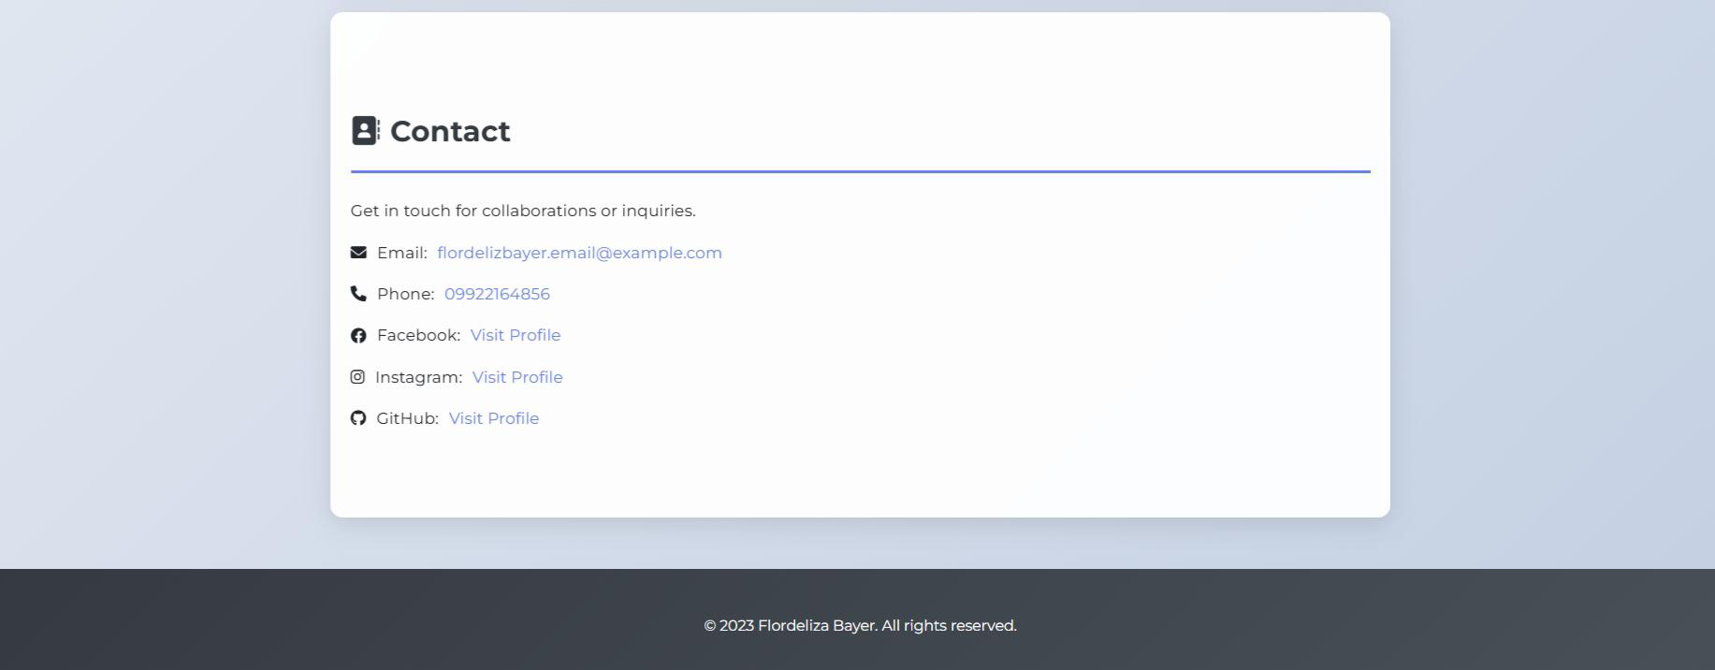

Fig. 9 Contact Information

Web Hosting Service’s Implementation
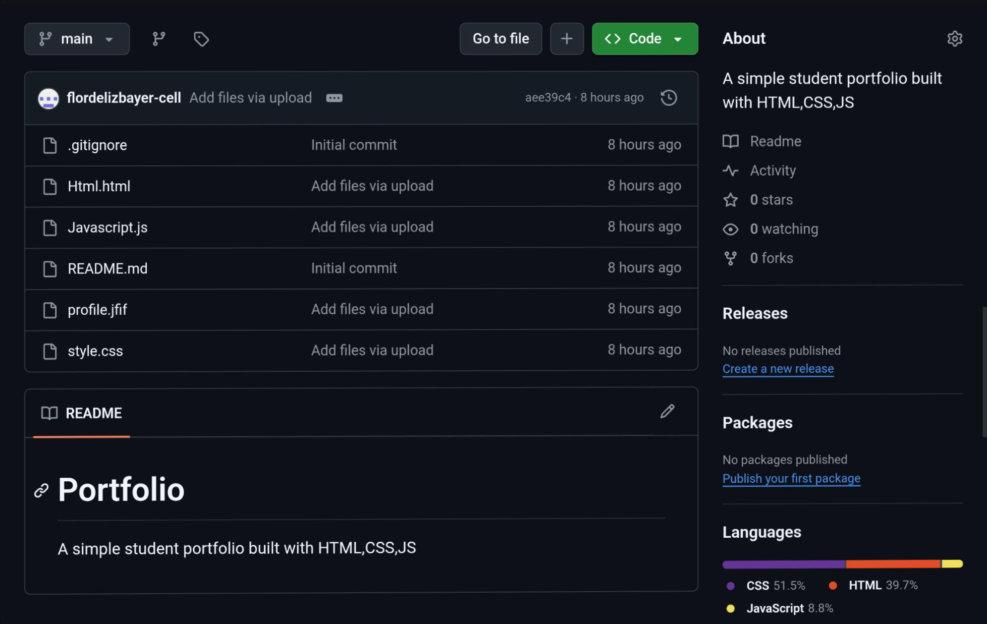

Fig. 10 Repository Code Tab


Fig. 11 Website’s URL Link

Fig. 13 Home page

Functionality Testing

The website was designed so users can scroll up and down to see all the different parts easily. It also has a navigation bar at the top, letting people quickly move between the home page, portfolio, and contact sections without searching around. Each navigation link was tested to make sure it went to the correct area or page. When moving through the website, scrolling felt smooth and all the details—like profile cards, buttons, and text boxes—were in their proper spots. After putting the website on GitHub Pages, some small problems came up, like missing pictures or files not showing. These issues were fixed by uploading the files again and fixing the folder setup. Testing continued on different browsers and devices, including phones, to see how the site looks for everyone. Opening the site in incognito mode helped check if it could handle more people at the same time. Other than a small wait when first loading, everything ran well and people could use the website without trouble

Recommendation For Future Work

While GitHub Pages made it possible to show the website online for free, it cannot support bigger ideas like sign-in forms or saving data from visitors. It might be more helpful to use websites like AWS or Netlify for future projects. These services can let you add more features, such as getting your own website name, having more control over changes, and supporting tools like search bars or blogs. Making the navigation bar more stylish, adding colorful effects when scrolling, and making sure the site works nicely on phones and tablets could make the website even better. Adding more sections to show school projects and giving visitors a way to contact or comment could also improve the site. With new hosting and updates, your next website can be larger, more interesting, and useful for more people.

Conclusion

Learning how to code a website was both exciting and challenging. At the start, it was tricky to put together all the pieces like wireframes, boxes, buttons, and links, making sure they looked good and worked the way they should. Sometimes, parts of the design did not line up, or files did not display correctly, which made it necessary to go back, fix the code, and try again. Adding features like scrollable layouts and a navigation bar took extra steps, but these made the website much easier for people to use and explore.

Working with GitHub Pages brought new lessons in web hosting. Uploading all the files to the GitHub repository needed careful organizing so that nothing went missing and all folders were in the right place. Sometimes, images or pages didn’t load after publishing, which meant learning how GitHub manages online websites and how to fix mistakes with file paths and updates. Adjusting the website and seeing the changes happen online was rewarding and showed the value of being patient and careful.

Overall, creating and hosting this website taught important skills: designing layouts, writing and fixing HTML and CSS, making pages scrollable, setting up navigation links, and understanding the basics of web hosting with GitHub Pages. These experiences, even when they were hard, will help with future projects and careers that use computers and technology. With good planning, practice, and effort, it’s possible to turn simple ideas into real websites that others can visit and enjoy.

References

About GitHub Pages – GitHub Docs. (n.d.). GitHub Docs. https://docs.github.com/en/pages/getting-started-with-github-pages/about-github-pages
What-is-aws. (n.d.). Amazon Web Services, Inc.
https://aws.amazon.com/what-is-aws/?nc1=f_cc

